**Course Available** [**https://citria.org/profile/course-available**](https://citria.org/profile/course-available)



The provided code is a React component named CourseAvailable. Let's break down its key features:

Imports:

The component imports necessary modules from React, including useState and useContext hooks, as well as components from React Router (Link and useNavigate). It also imports other components (PageTitle, Spinner, TermsModal) and custom hooks for API calls.

State Initialization:

The component initializes state variables using the useState hook for managing data related to enrolled courses (enrolledData), displaying toast messages (showToast), available courses (coursesData), and refund terms (refundTermsData). Additionally, there are state variables for managing the visibility of the terms modal (showTermsModal) and tracking whether terms are accepted (termsAccepted).

Functions:

handleCheckboxChange: Updates the state when the checkbox in the terms modal is clicked.

handleCheckoutButtonClick: Navigates to the checkout page if terms are accepted; otherwise, it opens the terms modal.

Rendering:

The component renders a page title, a section for displaying available courses, and a terms modal. It checks if there are courses available before rendering the course section.

Mapping Courses:

The component maps through the first four courses (coursesData?.slice(0, 4)) and displays information for each course, including title, cover photo, price, and enrollment status. It also renders buttons for continuing learning or initiating the checkout process.

Styling:

Tailwind CSS classes are used for styling, providing a responsive layout and visual elements.

Modal Usage:

The TermsModal component is rendered conditionally based on the showTermsModal state. It receives necessary props for managing its state and passing refund terms data.

Export:

The component is exported for use in other parts of the application.

Overall, this component represents a page displaying available courses, allowing users to check out and continue learning, with additional functionality for handling terms and conditions.

**Terms And Conditions**

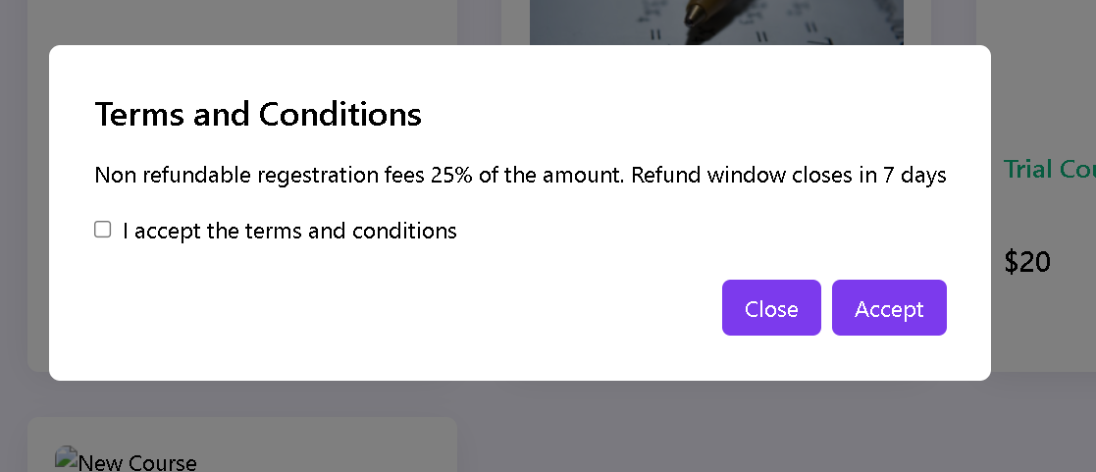

The provided code defines a React functional component named TermsModal. Let's break down its key features:

Props:

The component takes in several props, including isOpen to determine if the modal should be displayed, toggleModal to control the modal's visibility, onCheckboxChange to handle checkbox state changes, isChecked to represent the checkbox state, and refundTermsData for data related to refund terms.

Conditional Rendering:

The component uses a conditional rendering approach (isOpen && ...) to render the modal content only when the isOpen prop is true. This prevents the modal from being rendered when it's not needed.

Modal Structure:

The modal has a fixed position, covering the entire screen (fixed inset-0). It is styled to be a flex container, vertically and horizontally centered (flex items-center justify-center), with a dark semi-transparent background (bg-black bg-opacity-50).

The modal content is contained within a white background box with rounded corners (bg-white p-8 rounded-lg).

Content:

The modal includes a title "Terms and Conditions" (text-2xl font-semibold mb-4).

It displays information about non-refundable registration fees based on the provided refundTermsData. The refund window's closing duration is also mentioned.

A checkbox is provided for users to accept the terms and conditions (input type="checkbox"), and its state is controlled by the isChecked prop.

Buttons for closing and accepting the terms are present. The "Accept" button is disabled (disabled={!isChecked}) if the checkbox is not checked.

Styling:

Tailwind CSS classes are used for styling, providing a responsive layout and visual elements.

Event Handling:

Clicking on the buttons triggers the onClick event, calling the toggleModal function to control the modal's visibility. The onCheckboxChange function handles changes in the checkbox state.

Export:

The component is exported for use in other parts of the application.

Overall, this component represents a modal for displaying terms and conditions, allowing users to accept or close the modal. The design is responsive and follows best practices for modals in React applications.